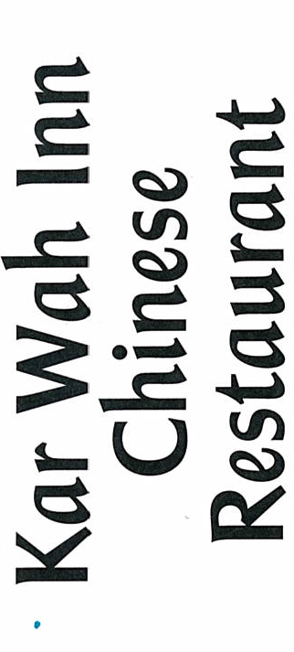

FINGER FOOD MENU
$15.00 PER PERSON
Chicken Nuggets
Fish Pieces
Sausage Rolls
Spring Rolls
Party Pies
Assorted Sandwiches
Frankfurts
Dim Sims

SMORGASBORG MENU
$20.00 PER PERSON
Mini Spring Rolls, Hokin Noodles, Fried Rice, Fish Pieces, Garlic Combination, Sweet and Sour Pork, Beef and Black Sauce
With Tea and Coffee

$25.00 PER PERSON
Mixed Entrée, Honey Chicken, Curry Prawns, Mongolian Combination, Fried Rice, Fish Pieces, Ham OR Chicken, Salad, Fruit Salad
With Tea and Coffee

$30.00 Per Person
Mixed Entrée, Honey Chicken, King Prawn Combination, Fried Rice, Sweet and Sour Pork, Pork Ribs in Plum Sauce, Roast Beef and Vegetables, Salad, Fruit Salad, Cheese Cake
With Tea and Coffee

